Food – Rice

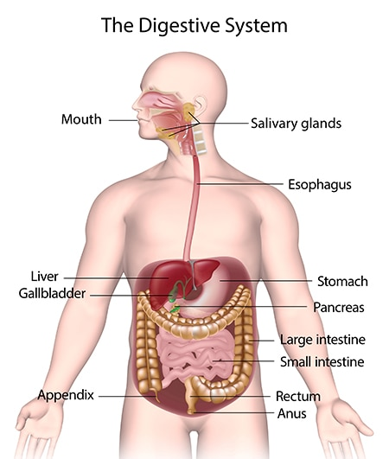Food Researching: Rice (Grain)

# Picture diagram of where the food will go throughout the absorption process

# **Mouth and Oesophagus:**

The rice is first enters the mouth which is where the digestion process beings. The mouth is now being chemically and mechanically processed with the grinding action from the teeth to breakdown the rice into smaller molecules to then being able to be digested. The salivary glands are then producing enzymes which are specifically called ‘salivary amylase’. To help break down the rice with the grinding action of the teeth to be able to be absorbed and digested by the body.

The rice is then passed on down through the Oesophagus which connects the mouth through to the stomach. As the food is now mixed with saliva which then forms a ball called the ‘Bolus’ and passes through the pharynx. It is now able to fit through the passageway with the help of the muscle contraction which then the rice is now being sent down into the stomach.

# **Stomach:**

Now that the rice is in the stomach, the stomach now starts both chemical and mechanical digestion which produces gastric acid produced by the gastric glands which chemically breaks down the food and its proteins and contents. The mechanical digestion is also in process as the stomach also breaks down the food until it becomes an acidic fluid ‘chyme’. This will make the chyme able to go through the small intestine.

# **Small Intestine Digestion:**

# Breakdown:

As the rice turns into chyme fluid, it then goes through into the small intestine. The small intestine is made out of three sections: duodenum, jejunum and ileum. The small intestine breaks down the rice chyme by the duodenum and the peristalsis. The duodenum and jejunum also help break down and absorb the rice chyme. After the process of breakdown in the small intestine, the nutrients and contents are now absorbed.

# Absorption:

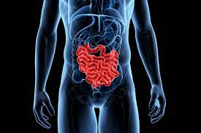After the breakdown the absorption process begins. The nutrients are then absorbed into the bloodstream and the amylase breaks down the starches of rice into sugars to be then metabolised and absorbed by the body and are the used for energy and growth. The nutrients absorbed are lipase for the lipids and protein for protease and also gain all the nutrients and vitamins needed for the body.

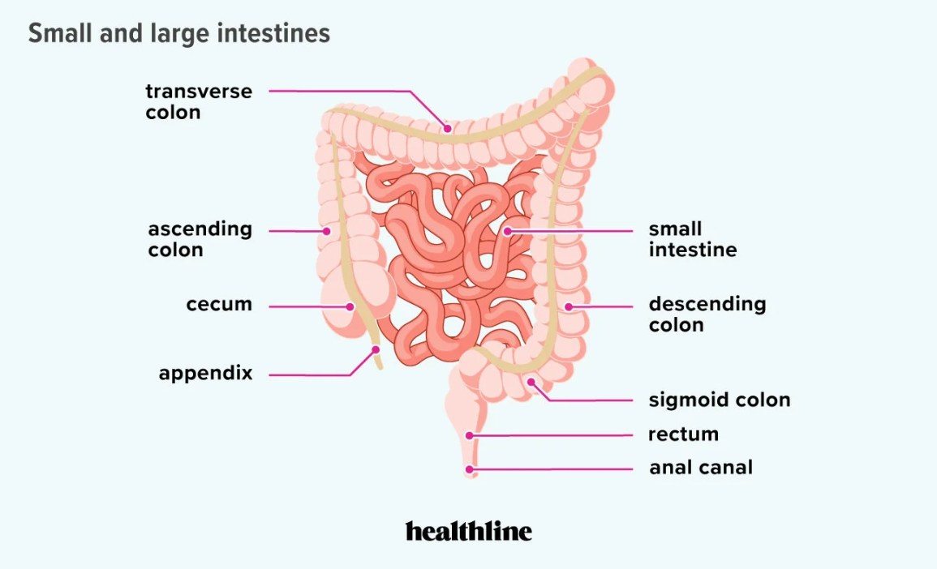

Image of the large and small intestine during Breakdown & absorption

<https://www.healthline.com/health/digestive-health/how-long-are-your-intestines#small-intestines>

https://www.livescience.com/52048-small-intestine.html

# **Material Breakdown and Use:**

The rice is absorbed and are used for energy in all sorts of functions from movement to growth. The amino acids from the rice nutrients are used for protein which then used for functions such as repair of the body especially wounds and scars.

# **Large Intestine Digestion:**

Now that the rice nutrients are absorbed. The leftover of the rice is now in a form of liquid which then goes through on to the large intestine. The large intestine also absorbs extra water before excreting and then turns all the remaining liquid into stool or faeces which then through the rectum.

# **Elimination and Faeces:**

After all the liquid and remaining food being processed and absorbed by the large intestine, it then excretes it into stool or faeces which contains undigested food waste and water, which then goes through to the rectum and then eliminated by the anus.

# **Sources Used (APA Format):**

1. *Describe the digestion of rice: type, location(s), enzyme(s), and chemical breakdown | Wyzant Ask An Expert*. (n.d.). Www.wyzant.com. <https://www.wyzant.com/resources/answers/778780/describe-the-digestion-of-rice-type-location-s-enzyme-s-and-chemical-breakd>
2. *What Happens To Your Body When You Eat Rice*. (2021, March 15). Eat This Not That.

<https://www.eatthis.com/news-what-happens-body-eat-rice/>

1. *How Is Rice Metabolized in the Body?* (n.d.). LIVESTRONG.COM. https://www.livestrong.com/article/553793-how-is-rice-metabolized-in-the-body/

‌